3d rendering
preserve colinearity and ratios of distances along a line
保持共线性和沿线距离的比率
can represented by using vectors and matrices
可以使用向量和矩阵表示
because you can represent them using matrices and combine them together they are really easy to work with on modern GPU’s.
因为您可以使用矩阵表示它们并将它们组合在一起，所以它们在现代GPU上非常容易使用。

parsing
An abstract syntax tree (AST) represents the abstract syntactic structure of the text.
• Each node of the tree denotes a construct occurring in the text.
• The syntax is ‘abstract’ in that it does not represent all the elements of the full syntax.
• Only keep things that are semantically meaningful.
抽象语法树（AST）表示文本的抽象语法结构。
•树的每个节点表示文本中出现的构造。
•语法为“abstract”，因为它不代表完整语法的所有元素。
•只保留语义上有意义的东西。

Concrete syntax trees (CPT) contain a lot of redundant information
具体语法树包含大量冗余信息

CPT created to exactly match the grammar. You can read off the original entence by traversing the tree depth first and reading off the leaves.
AST is without unneeded information to make it easy to work with and evaluate.

创建的CPT与语法完全匹配。 您可以通过首先遍历树深度并读取树叶来读取原始效果。
AST没有不必要的信息，因此易于使用和评估。

•[abc] describes a set of characters that can match
• \s, \t, \w match a space, tab, any white space
• \ is used as “escape” character when following character has non-standard meaning.
• x+ matches 1 or more occurrences of x.
x* matches zero or more occurrences of x. can be one

abc Matches “abc”
• a|e|i|o|u One of a, e, i, o, u.
• . Any character
• [0-9] [a-zA-Z] [+-*/] Sets of possible characters
• \d \s Digit, white space
• \. Dot

• \d+ One or more digits
• \d+\.\d* One or more digits, followed by decimal point, followed by zero or more digits
• \d+(\.\d*)? One or more digits, optionally followed by decimal point, followed by zero or more digits
• [a-zA-z][a-zA-z0-9]* Letter followed by zero or more letters and/or digits
• \w+\s\w+ Two words separated by one space

B tree & B+ tree
B+ trees have all data at leaf level, with links to next, so traversal is very easy.
B trees store both key and value in internal and leaf nodes
B+trees store key value pairs in leaf node. B+ trees only store keys in internal nodes, so it can store more keys in internal nodes and this is helpful when the value is big. Normally B+ tree is “busher” and the search is more efficient.
B +树在叶级别拥有所有数据，并且链接指向next，因此遍历很容易。
B树在内部和叶节点中存储密钥和值
B +树在叶节点中存储键值对。 B +树只在内部节点中存储密钥，因此它可以在内部节点中存储更多密钥，这在值很大时很有用。 通常B +树是“更加繁忙”，搜索效率更高。

Articulation point
1. Identifying nodes, exchanges, or connection points in a communications network that would disconnect the network if they became disabled.
2. Identifying key pipelines in a gas or similar supply network.
3. identifying intersection of city
1.识别通信网络中的节点，交换机或连接点，如果它们被禁用，将断开网络连接。
2.识别天然气或类似供应网络中的关键管道。

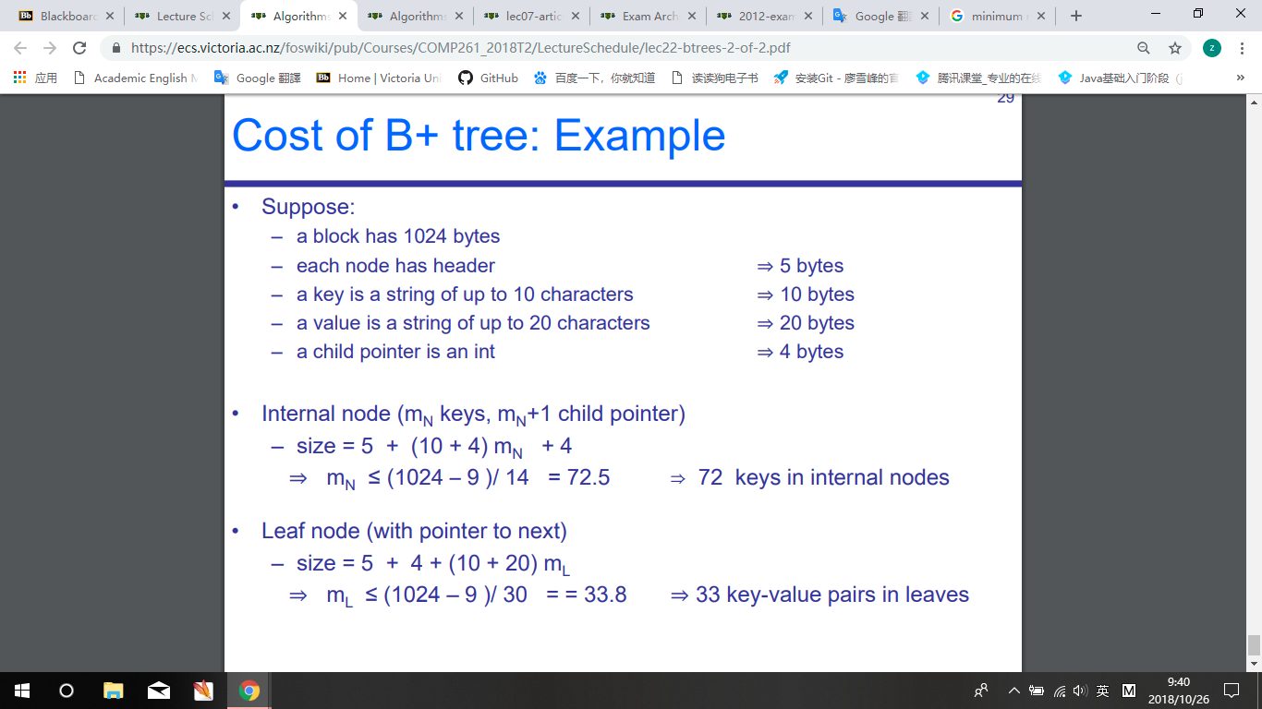
Internal node only have key
Left node contain key-value

